Topophilia

* Love of place
* Space filled with meaning (Yi-Fu Tuan 1930+)
* Book Topophilia in 1974
* Has own page at encyclopedia
* 4 reasons for developing affection for a place: home, memory, religion, imagination
* Home:
  + Nostalgia
  + Heritage tourism: people want to find their origin, Ancestry.com
  + Connection with home
  + Scottish Diaspora, Highland Homecomings Book (Paul Basu)
* Memory:
  + Capturing time
  + Place represents a memory captured in space
  + Ghost bikes, roadside crosses: memorial items fixed in place
  + Concretizing memory for people in that place
  + Memory and place are gendered (Marlene’s poems, ecocriticism)
  + Newfoundland: place is gendered
    - Male: described shores and fishing grounds
    - Female: layout of village, visits to neighborhood
  + Marlene Creates: Canadian artists and poet, cycle poems and photographs that related
  + to specific area in Nova Scotia
    - Book: Places, Paths, and Pauses (Marlene Creates) ecocriticism
    - Place not as a geographical location but as a process that involves memory
    - The intersection of art and the natural world on the level of the small-scale
    - With place, not as a geographical location, but as a process that involves memory, narratives, ecology, language
* Religion (sacred):
  + Places have a deep spiritual meaning for people (shrines, pilgrimage)
* Imagination:
  + Physical places become anchor for the mind’s creations
  + Disneyland, GoT, fantasy games, etc
  + Places that were filmed became popular due to fantasy films
* Affect: additional insight into the power of topophilia
  + Emotional, almost unconscious, reaction to the environment
  + Emotion: could be shivers of a feeling (frisson)
  + Environment: could be social, cultural or physical environment
  + These emotions may result in or enable some type of action
  + Agency: possess some power of affect (animals, plants)
  + John Wylie’s walk paper (was painful, place triggered a feeling or a sense)
  + Actor-Network Theory (ANT, body affected with landscape)
* Non-Representational Theory (NRT)
  + Tries to compensate for ANT’s neglect of human emotion by looking at what is happening outside of conscious though the moments of precognition.
  + Emphasizes affect, emotions that are embodied reactions to the social or physical environment
* Construct own places from topophilia: are places able to reach out to us? If so, how?
* Topophilia: we create a sense of place for ourselves (home, memory, religion, imagination)
* Genius loci/spirit of place: place can create an attachment among us (agency, affect, public religion, public imagination)
* Statues: do we give them meaning or they exert their own influence over us
* Topophilia can change over time: death makes memories fade, people change, settlers erase landscapes
* Yi-Fu Tuan: difficult to generalize from each person’s unique experiences of “place”.
  + We can generalize if we look at how each culture creates its own “place” or “region”
* Vidal de la Blanche: genre de vie
* Carl Sauer : cultural landscape
* Group :
  + Make each cultural region unique
  + Folk/vernacular architecture
  + Folk music
  + Ethnic or regional cuisine
  + Regional accent sand dialects
* Cultural landscape: The natural worlds -><- cultural practices of human groups
  + Overtime, the natural world and cultural practices of humans shape each other
  + Together create cultural landscape
  + Carl Sauer: geography must take the risks of interpreting the meeting of natural and cultural history (1956)
* Sauer and De la Blanche :
  + argued that each culture uniquely shapes and is shaped by its physical environment
  + Also produces its own unique cultural landscape that reflects and interacts with the physical environment
  + Ex: Carribean
    - Volcanoes and coral (lava and limestone)
    - Spanish, French, Dutch, English
    - We can see cultural and much as physical landscape
    - Landscape: landskip which means improved in Dutch
* Spectacular:
  + Created aesthetic
  + Changes over time
  + Is culturally based
  + Ex: Grand Canyon
  + Art: does it promote spectacular or ordinary landscape?
* Vernacular: native to its region, from the land of one’s birth (vernaculus In Latin = a slave born in his/her house)
  + Terry Jordan, Wilbur Zelinsky. Much of their work deals with issues such as folk housing
* Vernacular architecture, language, accents, music, food: distinctive features of a cultural region
  + Typical, diagnostic of a cultural region
    - Oldest types of buildings (local materials, old designs, old artisanal construction ways)
    - Centuries-old buildings that are more adapted to the local environment and built with more modern industrial techniques
  + Ordinary vs Spectacular:
  + Tim Robinson:
    - map of the Aran Islands
    - Stones of Aran: Pilgrimage book
    - Robert MacFarlane (Landmarks book)
    - Robinson circles the entire island in clockwise, sunwise fashion in search of the “good step: in which walking itself becomes a form of attention and contemplation
    - The power of language to shape our sense of place
    - Lieux de memoire: sites of memory, places important to group
    - Battle of the Heights of Abraham: Quebec City 1759
    - Statuses commemorate sites of memory so they aren’t lost
      * Memory changes? Memory lost?
  + Non-places:
    - Sense of placelessness
    - Ted Relph (UoT) student of Yi-Fu Tuan
    - Are they unmemorable? Topophobia?
  + Place marketing: Niagara Falls, heritage tourism
    - * Ideas of place are being used to sell something
  + Ordinary landscape: Terry Jordan, Wilbur Zelinsky (folk housing)
    - Open Air Museum in Stockholm, Sweden
    - Bucharest Folk Museum (corner joints)
    - Homeplace, UoT 1998 by petter Ennals and Deryck Holdsworth
    - Indigenous architecture (American/Canadian)
    - Fred B. Kniffen, Terry Jordan, Henry Glassie (1941-)
    - Henry Glassie: Pattern in the material Folk Culture of Eastern US 1968
      * History and stories are selective…whereas maps miss nothing
      * Film called Fieldwork, Turkey and NE Brazil
  + Classic small English or Irish cottage was the origins of the US house in E USA
    - New England (Cape Code house)
    - Mid-Atlantic (The I House)
    - Southern/Lower Chesapeake/Tidewater (Tidewater house)
  + New England Hearth: One-room English cottage -> Cape Cod, Salt Box House
  + Middle Atlantic Hearth: English cottage -> I House
  + Southern Hearth: English cottage -> Tidewater raised cottage (Southern hearth)
  + Shotgun: Jordan’s Southern Hearth, used for slaves (AD Iselin), from Africa to Haiti
  + Log Cabin: Jordan’s Middle Atlantic Hearth, used for slaves
  + Skansen Open-Air Museum, Stockholm, Sweden

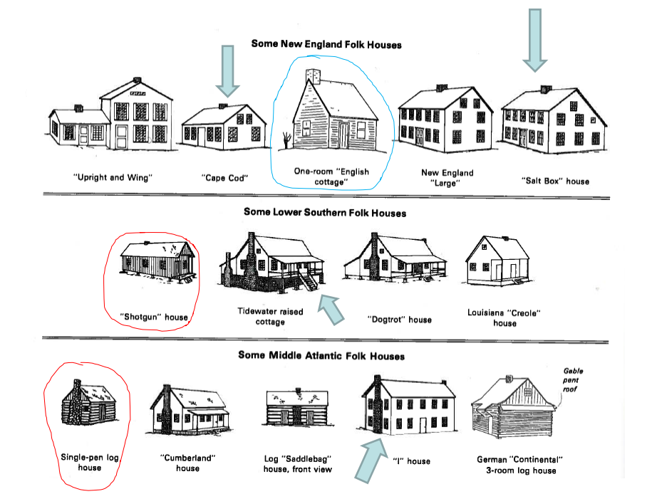

* Cultural flow is not all one way across the Atlantic
  + Diffusion: USA vernacular housing designs taken back to W. Africa by freed slaves settled in Liberia
  + Terry Jordan researched Fed B Kniffen’s work
  + Terry Jordan researched log cabins in Northern and Central Europe
    - Based on pattern of joints
    - Barns raised up away from rats
    - Farmhouse and old fences
    - Old breed of pigs
* Historical Atlas of Canada Vol2, Canadian Folk Architecture, Vernacular Architecture in Canada 1993
* 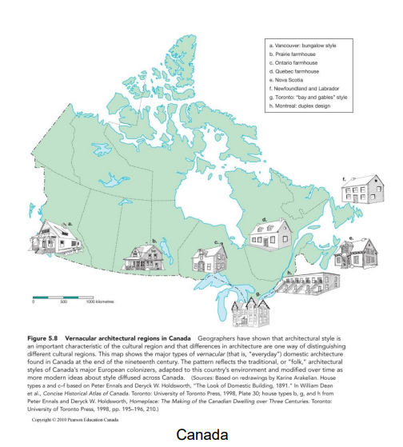
  + Quebec 17/18th century: folk housing based on cottages found in France
  + Ontario 18/19th century: stone farmhouses built by Loyalists from USA
  + Newfoundland 18/19th century: Irish/British fishing people bring designs
  + Prairies 19th century: many Central European (Ukraine) designs
  + BC 19/20th century: bungalow design
* Ontario and Quebec farmhouses were urbanized (postmodernism)
* Place marketing: moving old houses, assurance of quality?
  + Cottage style in 1930’s gas stations
  + New England cottage on Rhode Island house
  + Facadism: original front kept on new building (indicates value of heritage)
  + Some buildings deny their place: TD Bank Towers in Toronto, Guggenheim Museum in Bilbao Spain
* Caribbean Quarterly book

Language:

* A means of communicating ideas or feelings by signs, gestures, marks or articulate vocal sounds
* Geography of Language, dialects, language and regional identity
* Geography of world languages
  + Mother tongues, Indo-European Languages: Outcome of:
    - Innovation: isolation and time
    - Diffusion: spread from one place to another
  + Countries with Indo-European Languages are dominant (1492+)
  + African Languages: Bantu or Niger-Kordofanian Languages are dominant in South Africa
  + Afro-Asiatic: Dominant in North Africa and Middle East
* Family Tree of Language: Scientific American 1991
  + Original Language: only reasonable guesses about what the first/original language may have sounded like
  + Indo-European: Sir William Jones (1786) observed similarities between Sanskrit (ancient East Indian) and European languages
    - How dissimilar Indo-European is from other non-Indo-European
    - Includes almost all languages except:
      * Finnish, Estonian and language family)
      * Basque (NE Spain, SW France) isolate language
      * Bogdan Zaborski: Concordia professor mapping languages
    - Origins: where it began? How did it spread?
      * University of Chicago Press 1970: Proto-Indo-European Trees
      * Invading nomadic hordes brought it from the Russian steppes
      * Turkey/Armenian area: suggests Turkey is the source (Anatolia), spread from ME across Europe 10,000 years ago by farmers, diffusion of agriculture across continent
      * 1990 view: circle around the Caucasus region
      * 1989 Renfrew view: diffused across from Anatolia
      * Can we figure origin using the environment? Many have tried
  + Austronesian family: from Madagascar to Eastern Islands (Random House London, 1997)
    - If we leave Indo-European, there are other language families that have spread far
    - Austronesian: Micronesia, Polynesia, Melanesia, Island Southeast Asia
    - Spread of Austronesian westwards by about 500 AD brought to Madagascar by Indian Traders
    - Austronesian languages of Madagascar, not related at all to those of Africa
    - Australian Aboriginal languages NOT Austronesian
      * So old, we can’t see how they fit into our family tree of world languages
      * No generally accepted genetic connection, geographic isolation
    - Dravidian tongues such as Tamil, Telugu, Kannada

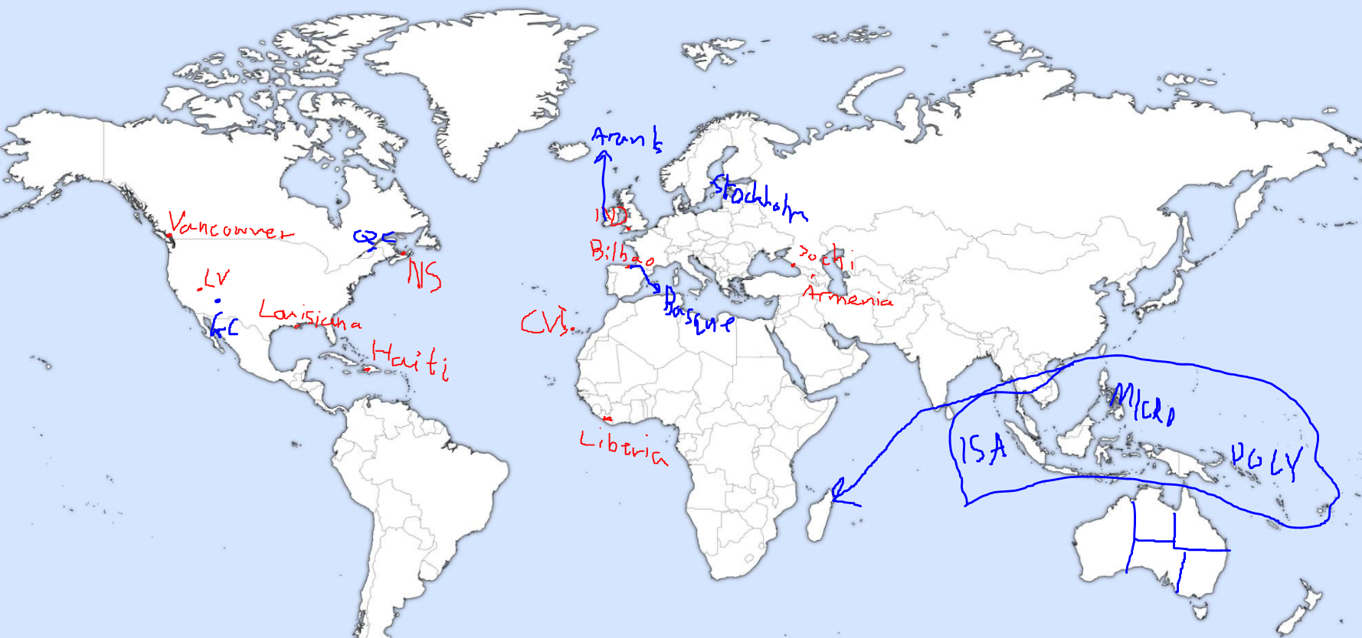

Dialect:

* Regional variations from standard language in terms of: accent, vocabulary, grammar
* Vernacular: local, native
* Development: by prolonged isolation from speakers of the same language, through migration
* Accent: “creek” in 3 different USA cultural hearths
  + Northern (New England) and Midland (Mid Atlantic) areas say “creek” to rhyme with “crick”
  + Southern (Chesapeake, or Tidewater) say “creek” to rhyme with “creak”
  + Same pattern of three cultural hearths as vernacular houses
* Vocabulary: varies across space
  + Example of “silly” in England
  + Pop/soda in USA
  + South America
* Grammar: how sentences are constructed, expressions vary regionally
  + Not a national standard, but a dialect expression
  + How we tell time? 11:35 PM
  + “Eleven thirty-five”, “five and twenty to twelve”, “twelve past twenty five”
* Italian Nones Dialect vs Standard Italian :
  + Spoken in the South Tyrol of Northern part of Italy, subtle differences
* Migration and Isolation:
  + New Worlds, old words: language escapes change in vocabulary, grammar from origin
    - regional Greek dialect better preserved in Montreal than Greece
    - gallied: perplexed by being hunted (Moby Dick, 1851)
    - gally: frighten excessively
    - gallow: to fear (King Lear by Shakespear)
    - France 1798: too many dialects, eliminating them to better govern country
  + “When people move, their language escapes changes that occur at home”
    - French in Quebec
  + “When people move, their language undergoes considerable change”
    - English in Newfoundland
  + New Worlds, new words:
    - Newfoundland: settled from 17th century by English speakers from Western England and Ireland.
      * Vocabulary: new words for new environments
        + “Ballicatter = new words for ice
        + “bedlamer” = immature seal
        + “penguin” = originally for the Greak Auk
        + “welsh” = for white bread
      * Grammar: “How many times am I after telling you…”
      * Pronunciation: A distinct Irish/west of England accent
* Pidgin and Creole:
  + Although languages get divided, languages can combine with other languages to produce hybrid forms
  + Pidgin: system of communication which has grown up among people who do not share a common language, but who want to talk to each other, trade, etc (The Cambridge Companion to Language 1987)
    - Basque whalers and native people of the lower St Lawrence in the 16th century
  + Creole: pidgin language which has become the mother tongue of a community (pidgin and creole are distinct processes of linguistic development)
* Language and regional identity:
  + Because language is spoken by people who occupy space and is an intrinsic part of culture, it is not surprising that language has always been an important characteristic of the cultural region
  + Many groups speak with pride about their language and will strongly identify with it, using language as part of the means to establish ethnic, regional, and national differences
  + Quebec: concern about declining birth date and language shift of immigrants (French to English)
    - Nationalist project designed to increase the use of French
    - Language shift: number of people who adopt a new language (mother tongue)
  + Canada’s Indigenous People:
    - Decline of Aboriginal landscapes (worldwide phenomena)
    - Secure aboriginal languages: Cree, Ojibway, Inuktitut, rest at least 12 are in danger of extinction
    - Loss of language does not equate with death of the culture, but it can severely handicap its future” (Statistics Canada)
    - Dictionary: English-Eskimo
  + Rest of Canada:
    - Predominantly anglophone
    - Changing pattern of immigration means that the leading allophone languages spoken at home have changed from Italian (in 1971) to Chinese (1996)
    - Because immigration is largely an urban phenomenon, the effects of recent flows have impacted Canada’s cities